

**Carrier 1.5 Ton**

**Rs. 180,000/-**

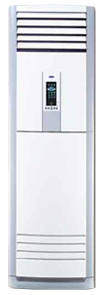

**Product Features**

* evaporator self-cleaning
* Inner brass screw high efficiency exchange heat
* auto mode
* Ultra-Thin Design
* High Efficiency Filter

**Specification**

**Type** Wall Mounted Split AC

**Cooling (Btu/h)** 39000

**Voltage (V)** 220-240

**Power Input (W)** 4800

**EER (Btu/W-h-W/W)** 7.1-3.75